Train tiếp: make training MODEL_NAME=my-lang START_MODEL=vie TESSDATA=../tessdata/ MAX_ITERATIONS=500 LEARING_RATE=0.001

Train mới : make training MODEL_NAME=my-lang TESSDATA=../tessdata/ MAX_ITERATIONS=5000 LEARNING_RATE=0.002

Sinh ảnh: python run.py -c 10 --dict dicts/vi.txt --font fonts/vi/times.ttf -w 5 -f 64

Video hướng dẫn: <https://www.youtube.com/watch?v=SvhoBT-PnME&list=LL&index=6&t=1119s>

1. <https://github.com/UB-Mannheim/tesseract/wiki>

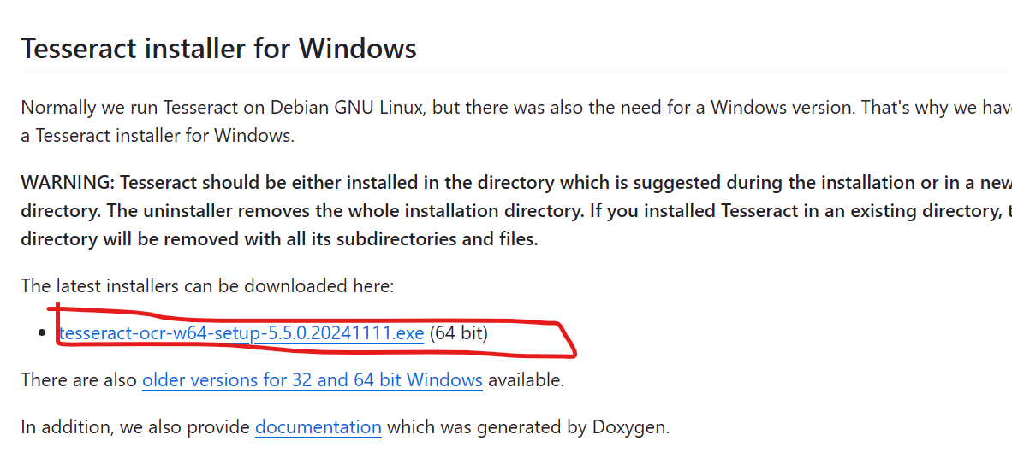

1. https://github.com/tesseract-ocr/tesstrain

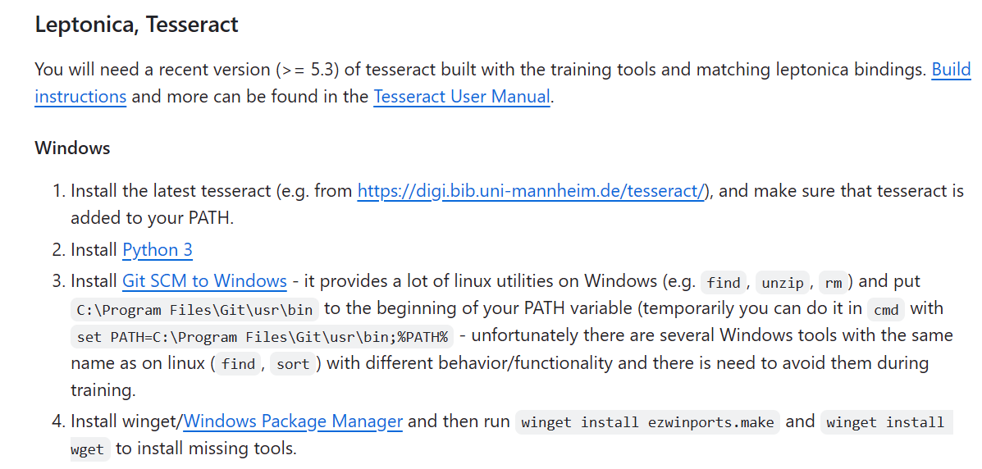

Tải Git SCM to Windows